NAME: VIJAYALAKSHMI S
REG NO:192472326
Section 1: Intelligent Email and Password Validator using Regular Expressions

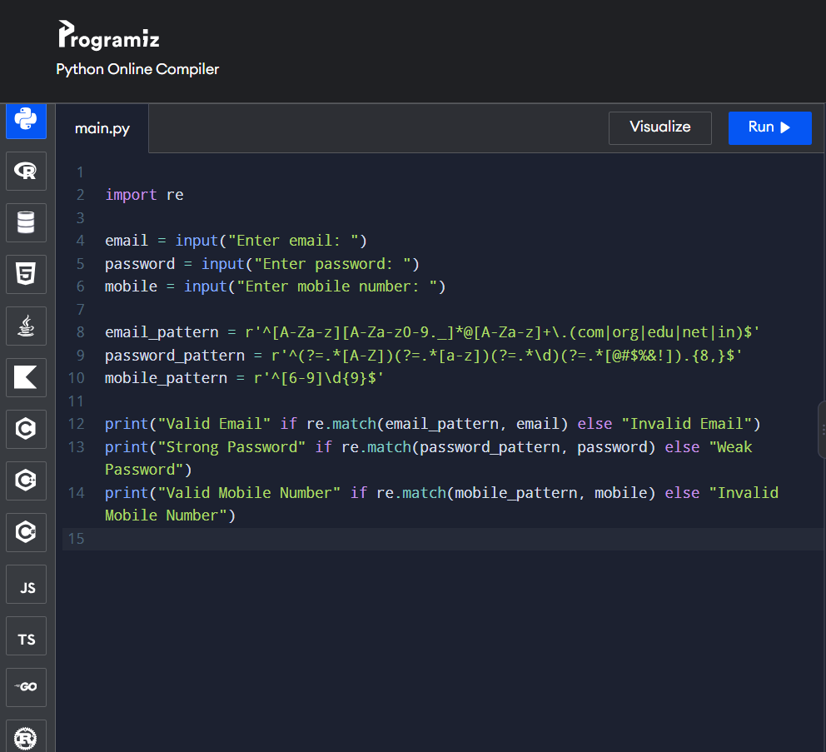
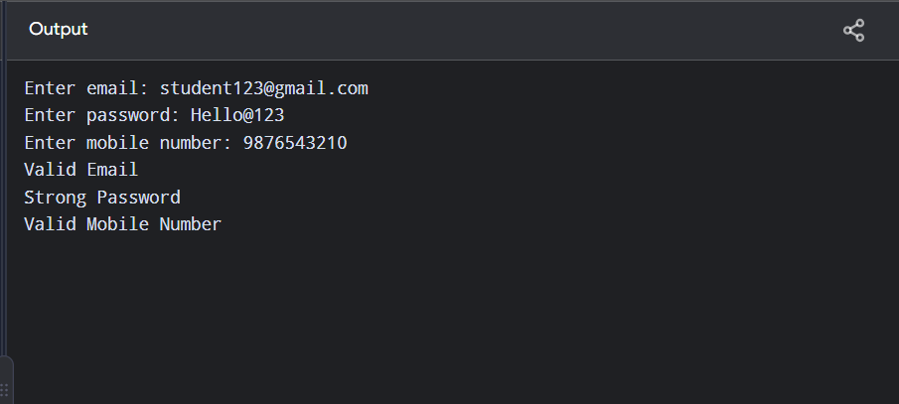
Section 2: Design a Finite State Automata (FSA) Simulator

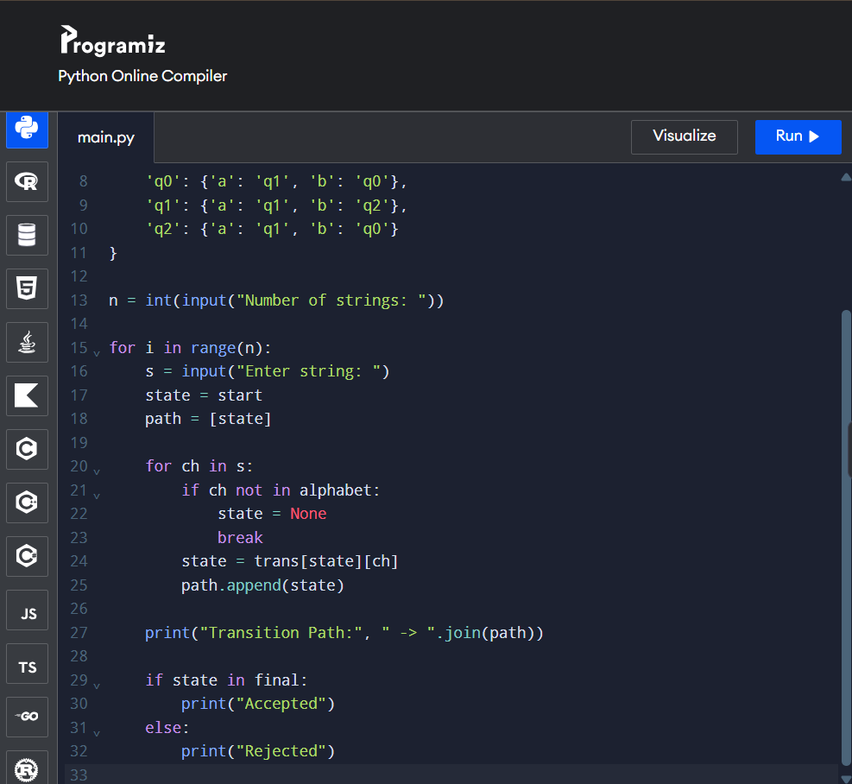
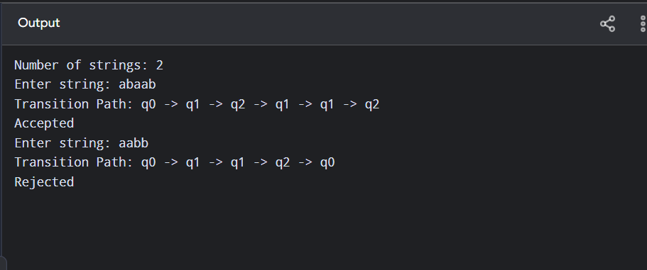

Section 3: Smart Pattern Matching Engine using Regular Expressions

